# LAPORAN PRAKTIKUM INTERNET OF THINGS (IoT)

# Fakultas Vokasi, Universitas Brawijaya

**Praktik Pembuatan Traffic Light ESP32**

*Faiz Henri Kurniawan*

*Fakultas Vokasi, Universitas Brawijaya*

*Email: faizhenrik@student.ub.ac.id*

**1. Introduction**

Membuat rangkaian Lampu Lalu Lintas (Traffic Light), Terdiri dari 3 LED berwarna hijau, merah, dan kuning. Menyala secara bergantian.

**1.1 Latar belakang**

Mempersiapkan akun untuk pemelajaran dan pelaporan progress ke depan

**1.2 Tujuan eksperimen**

Membuat rangkaian dan code traffic light

**2. Methodology (Metodologi)**

**2.1 Tools & Materials (Alat dan Bahan)**

1. Wokwi
2. Github
3. Vscode

**2.2 Implementation Steps (Langkah Implementasi)**

1. Edit Rangkaian di Wokwi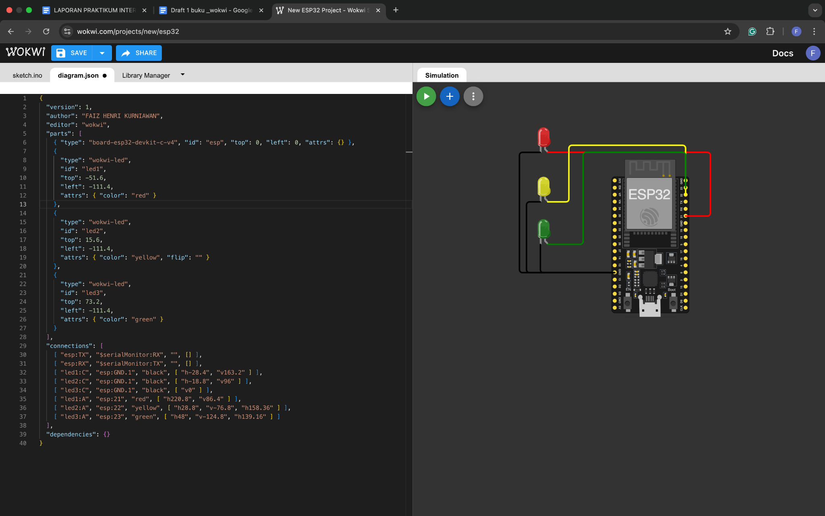
2. Copy *diagram.json* untuk di vscode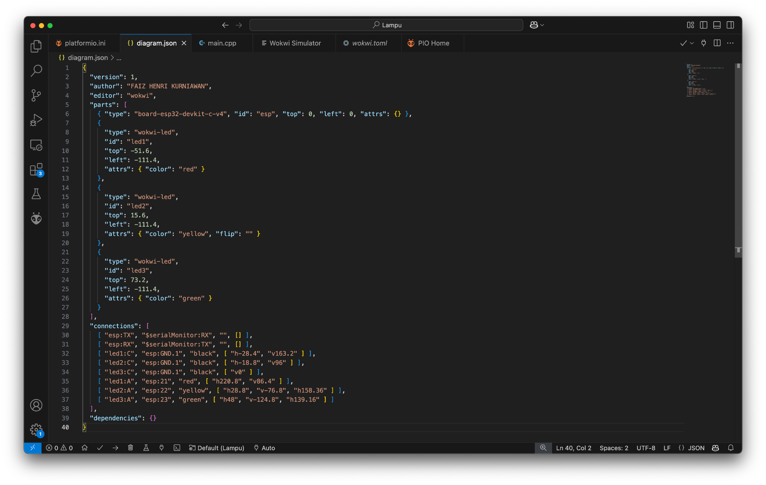
3. Buat Code untuk traffic light yang akan menyala sesuai dellay yang di atur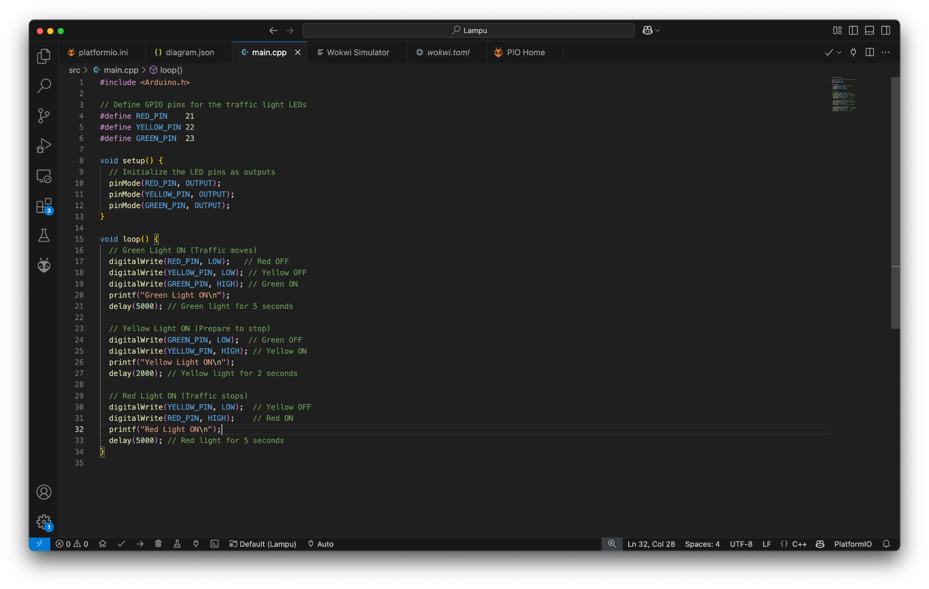

**3. Results and Discussion (Hasil dan Pembahasan)**

**3.1 Experimental Results (Hasil Eksperimen)**

**4. Appendix (Lampiran, jika diperlukan)**

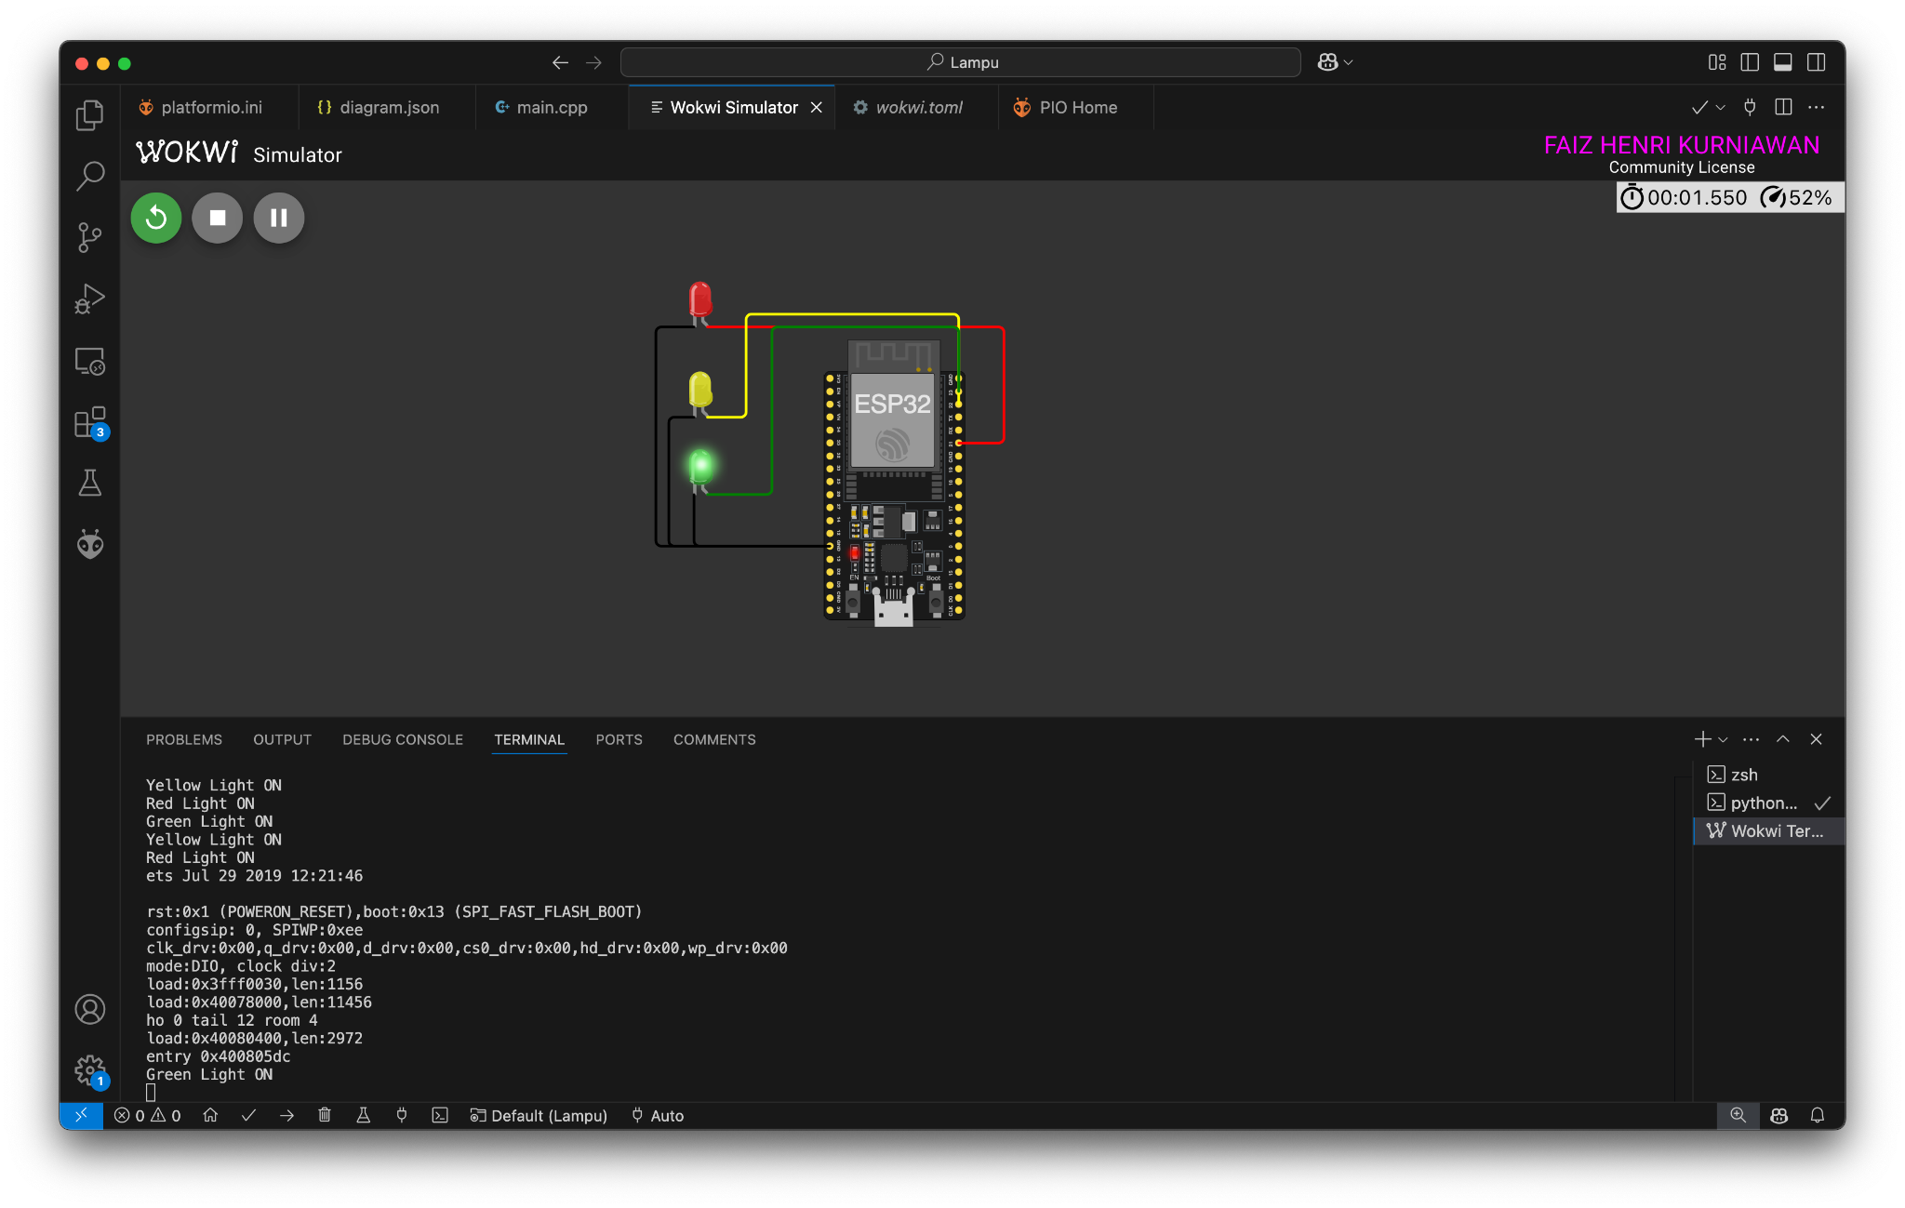

Lampu Menyala sesuai code yang kita buat.

Code traffic   
#include <Arduino.h>

// Define GPIO pins for the traffic light LEDs

#define RED_PIN 21

#define YELLOW_PIN 22

#define GREEN_PIN 23

void setup() {

// Initialize the LED pins as outputs

pinMode(RED_PIN, OUTPUT);

pinMode(YELLOW_PIN, OUTPUT);

pinMode(GREEN_PIN, OUTPUT);

}

void loop() {

// Green Light ON (Traffic moves)

digitalWrite(RED_PIN, LOW); // Red OFF

digitalWrite(YELLOW_PIN, LOW); // Yellow OFF

digitalWrite(GREEN_PIN, HIGH); // Green ON

printf("Green Light ON\n");

delay(5000); // Green light for 5 seconds

// Yellow Light ON (Prepare to stop)

digitalWrite(GREEN_PIN, LOW); // Green OFF

digitalWrite(YELLOW_PIN, HIGH); // Yellow ON

printf("Yellow Light ON\n");

delay(2000); // Yellow light for 2 seconds

// Red Light ON (Traffic stops)

digitalWrite(YELLOW_PIN, LOW); // Yellow OFF

digitalWrite(RED_PIN, HIGH); // Red ON

printf("Red Light ON\n");

delay(5000); // Red light for 5 seconds

}

Diagram.json

{

"version": 1,

"author": "FAIZ HENRI KURNIAWAN",

"editor": "wokwi",

"parts": [

{ "type": "board-esp32-devkit-c-v4", "id": "esp", "top": 0, "left": 0, "attrs": {} },

{

"type": "wokwi-led",

"id": "led1",

"top": -51.6,

"left": -111.4,

"attrs": { "color": "red" }

},

{

"type": "wokwi-led",

"id": "led2",

"top": 15.6,

"left": -111.4,

"attrs": { "color": "yellow", "flip": "" }

},

{

"type": "wokwi-led",

"id": "led3",

"top": 73.2,

"left": -111.4,

"attrs": { "color": "green" }

}

],

"connections": [

[ "esp:TX", "$serialMonitor:RX", "", [] ],

[ "esp:RX", "$serialMonitor:TX", "", [] ],

[ "led1:C", "esp:GND.1", "black", [ "h-28.4", "v163.2" ] ],

[ "led2:C", "esp:GND.1", "black", [ "h-18.8", "v96" ] ],

[ "led3:C", "esp:GND.1", "black", [ "v0" ] ],

[ "led1:A", "esp:21", "red", [ "h220.8", "v86.4" ] ],

[ "led2:A", "esp:22", "yellow", [ "h28.8", "v-76.8", "h158.36" ] ],

[ "led3:A", "esp:23", "green", [ "h48", "v-124.8", "h139.16" ] ]

],

"dependencies": {}

}